Syeda Reeha Quasar

14114802719

4C7

Aim

Write a program to take name, address as character string, age as int, salary as float and contains inline function to set the values and display them.

Experiment - 2

Object Oriented Programming Lab

# **EXPERIMENT – 2**

## **Aim:**

## Write a program to take name, address as character string, age as int, salary as float and contains inline function to set the values and display them.

## **Source Code:**

#include <iostream>

#include <string>

using namespace std;

class details{

    public:

        string name;

        string address;

        int age;

        float salary;

    void getData() {

        cout << "Enter name" << endl;

        getline(cin, name);

        cout << "Enter address" << endl;

        getline(cin, address);

        cout << "Enter age" << endl;

        cin >> age;

        cout << "Enter salary" << endl;

        cin >> salary;

    }

    void showdata();

};

void details :: showdata(){

    cout << "details of employee \n";

    cout << "name: " << name << endl;

    cout << "address: " << address << endl;

    cout << "age: " << age << endl;

    cout << "salary: " << salary << endl;

}

int main(){

    details d;

    d.getData();

    d.showdata();

    return 0;

}

## **Output:**

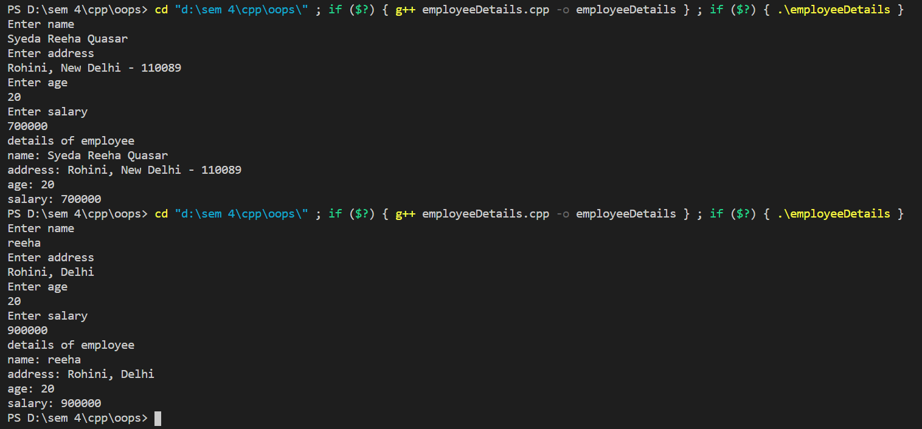

# **Viva Questions**

### **1. What are the C++ access specifiers?**

Ans.

In C++ there are the following access specifiers:

**Public:** All data members and member functions are accessible outside the class.

**Protected:** All data members and member functions are accessible inside the class and to the derived class.

**Private:** All data members and member functions are not accessible outside the class.

### **2. Define inline function**

Ans.

If a function is inline, the compiler places a copy of the code of that function at each point where the function is called at compile time. One of the important advantages of using an inline function is that it eliminates the function calling overhead of a traditional function.

### **3. What is a reference in C++?**

Ans.

A reference is like a pointer. It is another name of an already existing variable. Once a reference name is initialized with a variable, that variable can be accessed by the variable name or reference name both.